Alien Treasure Hunt
Ensure you are never an alien on this planet by finding these treasure plants hiding around Woodloes:
150 Points | Where?
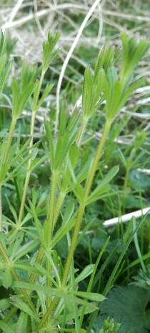 | Hedges
 | Danger Level
 | 10 – a bit sticky
 | Fact
 | It is covered in little hooks and has lots of names: Cleavers, Goose Grass, and Sticky Willie.
Name: Sticky Weed
200 Points | Where?
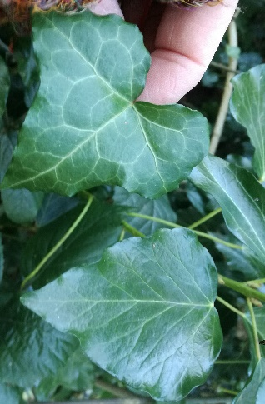 | Climbing trees and over the ground
 | Danger Level
 | 200 - Poisonous
 | Fact
 | The Leaves have two different shapes. It has strange flowers and berries in the Autumn.
Name: Ivy

100 Points | Where?
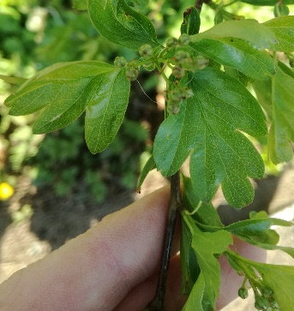 | Hedges
 | Danger Level
 | 50 – sharp thorns
 | Fact
 | Also known as “The May Tree” (it flowers in May) and “Bread and Chaeese”.
Name: Hawthorne

300 Points each | Where?
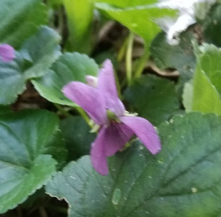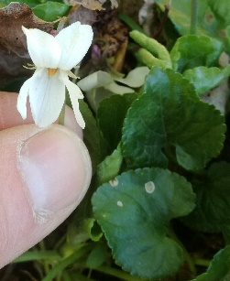 | Woods and hedges
 | Danger Level
 | 20 – its smell is weird
 | Fact
 | The smell is anaesthetic and makes your nose unable to smell anything for a minute.
Name: Violets and White Violets
200 Points | Where?
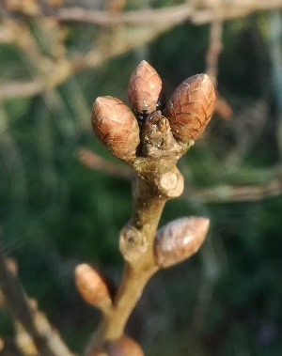 | Large trees
 | Danger Level
 | 10 – bitter tasting
 | Fact
 | It has been a wet Winter so the oak trees will be last to come into leaf this year – do you believe me?
Name: Oak
250 Points | Where?
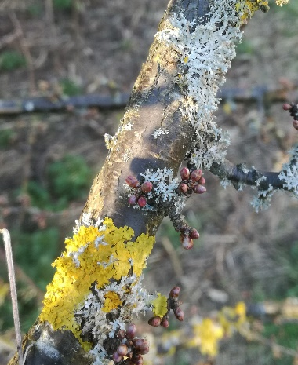 | Branches and walls
 | Danger Level
 | 0
 | Fact
 | Lichens are made up of a fungus (mushroom) that supports microscoptic plants called algae. The plants have somewhere to live and they feed the fungus; so everyone is happy.
Name: Sun Burst Lichen
and Oak Moss Lichen
150 Points | Where?
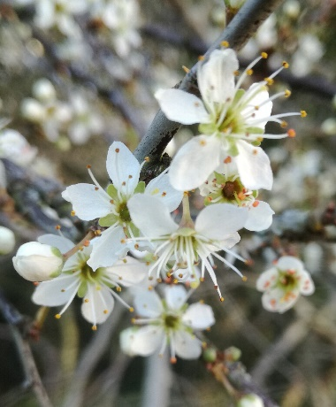 | Small Trees
 | Danger Level
 | 30 – beware cyanide!
 | Fact
 | Plums, Almonds, Peaches, Nectarines, and Blackthorn (Sloes) are closely reated and all put cyanide into their seeds.
Name: Plum and Blackthorn

300 Points | Where?
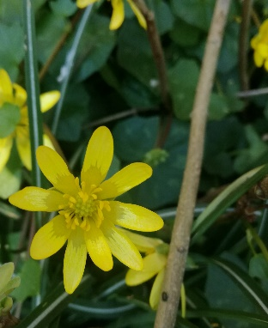 | Hedges
 | Danger Level
 | 10
 | Fact
 | The close up at night like daisies do.
Name: Lesser Celandine

250 Points | Where?
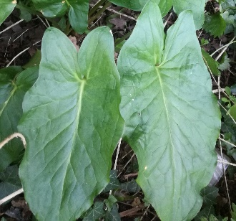 | Under Hedges
 | Danger Level
 | 500 - Poisonous
 | Fact
 | Cuckoo Pint is poisonous, so wash your hands if you touched it! It has lots of different names like Arum Lily and Lords and Ladies. The flower is like a big, green bottle with a little stick in the middle. Some people say it looks like a little man with a cloak on; a lord. Later in the year the stick in the middle of the flower makes a clump of red berries which are POISONOUS! But that’s not all! Its also a fly trap! The flower captures midges in its base, Then it closes up and keeps them there all night, It even feeds them! But it doesn’t eat them, it lets them out in the morning covered in pollen!
Name: Cuckoo Pint

2500 Points | Where?
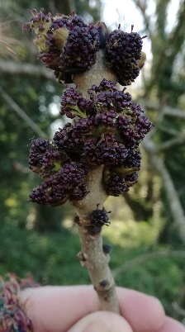 | Tall Trees
 | Danger Level
 | 250 – beware falling branches
 | Fact
Ash trees are being killed by a fungus that makes them drop their branches.

Prize for the weirdest flowers!
Name: Ash Tree Flowers

200 Points | Where?
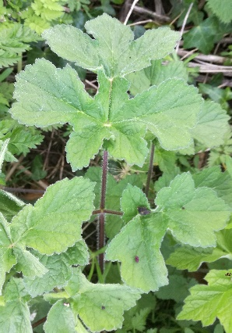 | Hedges
 | Danger Level
 | 50 – smells of pigs
 | Fact
 | It makes umbrellas of flowers that can be confused with the most deadly plants in the country: hemlock, fools parsley, and water drop wort.
Name: Hogweed

100 Points | Where?
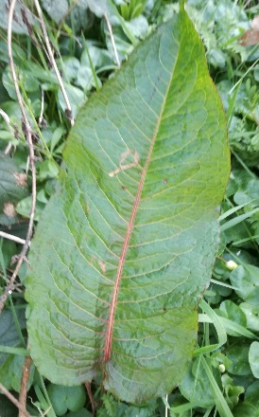 | Hedges
 | Danger Level
 | 0
 | Fact
 | You can rub it on a sting to cure it; but it’s not as good as plantain!
Name: Dock
350 Points if you find both | Where?
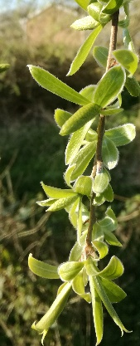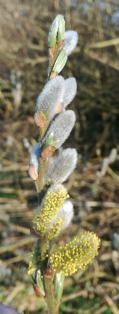 | Trees
 | Danger Level
 | 0 – just too soft
 | Fact
 | Willow bark is used to make aspirin (old fashioned Calpol). You can use it’s young branches to weave into wicker work baskets and chairs.
Name: Weeping Willow and Goat Willow Flowers

