Reading Plants
Growing Around Woodloes
- Look for little white and yellow flowers on the grass…
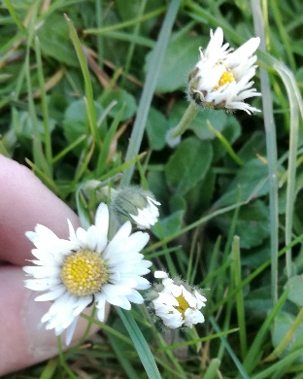 | look closer…  Are there little bits of pink on the petals?  Does the centre feel soft like velvet?  Do they close up at night?  You have found Daisies!  They are called daisies (day’s eyes) because they open in the day and close at night; like your eyes.
- Look for a plant with spiky leaves that grows in clumps.
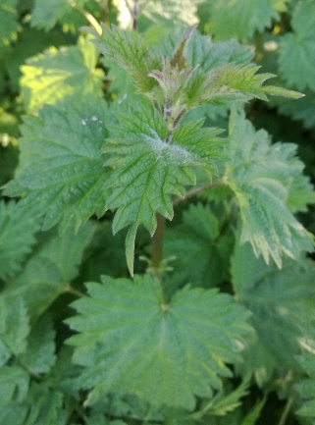 | look closer… but don’t touch!  Are there NO flowers on it?  Are there tiny spikes all over it?  You have found Stinging Nettles!  Be careful those tiny spikes are as sharp as needles and will sting you! But if you cut the nettle down then they quickly go soft because they are held up by water.
Now for something more difficult….

- Look for a tree with stripy bark
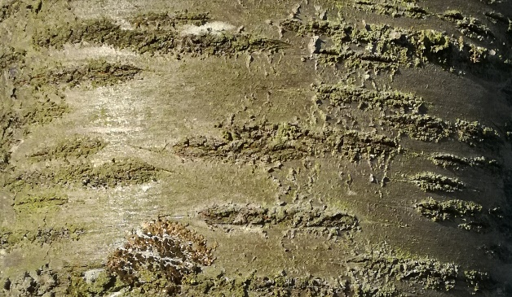 | look closer…  Is the bark a reddish brown?  Does it have top branches that reach straight up to the sky?  Are flowers just starting to open on its branches?  You have found a Cherry Tree!

- Look for tiny green plants, usually growing on a wall or in a crack.

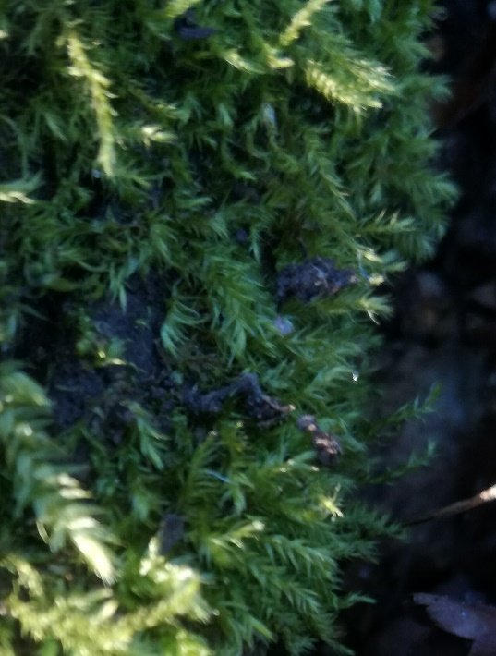 | look closer…  Is it soft to touch?  Is it damp or soggy?  When you look really closely does it look like a forest of tiny trees?  You have found Moss!  Moss is one of the simplest plants. It has been growing on land since before the dinosaurs lived. It is so simple that doesn’t have anything stiff in it to hold it up; which is why it is always soft and tiny.
- Look for a plant with arrow shaped leaves under a hedge.
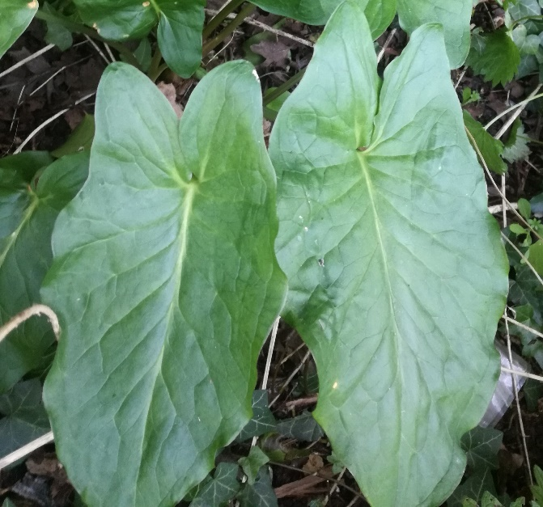 | look closer… But don’t touch!  Are the leaves glossy and shiny?  Are there black spots on some of the leaves?  You have found Cuckoo Pint!  Cuckoo Pint is poisonous, so wash your hands if you touched it! It has lots of different names like Arum Lily and Lords and Ladies. The flower is like a big, green bottle with a little stick in the middle. Some people say it looks like a little man with a cloak on; a lord. Later in the year the stick in the middle of the flower makes a clump of red berries which are POISONOUS! But that’s not all! Its also a fly trap! The flower captures midges in its base, Then it closes up and keeps them there all night, It even feeds them! But it doesn’t eat them, it lets them out in the morning covered in pollen!
If you have enjoyed reading these plants, you might want to look for the plants in the KS2 children’s treasure hunt.

